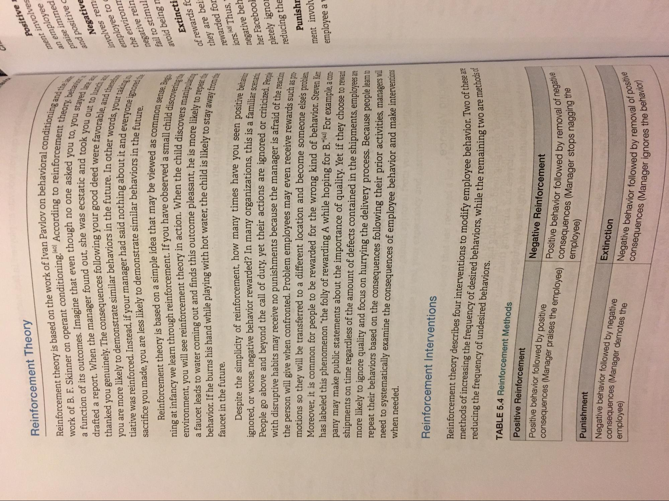
Reinforcement Theory
Positiv ment involt an employe praise imme and positive
Negati
Reinforcement theory is based on the work of Ivan Pavlov on behavior work of B. F. Skinner on operant conditioning. According to reinfor a function of its outcomes. Imagine that even though no one asked drafted a report. When the manager found out, she was ecstatic and to thanked you genuinely. The consequences following your good deed you are more likely to demonstrate similar behaviors in the future. In other tiative was reinforced. Instead, if your manager had said nothing about it an sacrifice you made, you are less likely to demonstrate similar behaviors in the
Reinforcement theory is based on a simple idea that may be viewed ning at infancy we learn through reinforcement. If you have observed a small environment, you will see reinforcement theory in action. When the child die a faucet leads to water coming out and finds this outcome pleasant, he is more li behavior. If he burns his hand while playing with hot water, the child is likely to faucet in the future.
vioral conditioning and inforcement theory, beha ked you to, you stayed a and took you out to lun a were favorable, and the bother words, your taking
ut it and everyone ignored viors in the future. ved as common sense. Bes
mall child discovering hild discovers manipulatos
is more likely to repeat te d is likely to stay away from the
involves rel employee to the environ negative rei fail to stimu
avoid being
Extinct of rewards they are be rewarded fo jors. Thus, negative bel her Faceboo
ou seen positive behavice his is a familiar scenarin
ed or criticized. People
Despite the simplicity of reinforcement, how many times have you seen nos ignored, or worse, negative behavior rewarded? In many organizations, this is a fami People go above and beyond the call of duty, yet their actions are ignored or criticise with disruptive habits may receive no punishments because the manager is afraid of the the person will give when confronted. Problem employees may even receive rewards such motions so they will be transferred to a different location and become someone else's problem Moreover, it is common for people to be rewarded for the wrong kind of behavior. Steven Ker has labeled this phenomenon “the folly of rewarding A while hoping for B."[41] For example, a com pany may make public statements about the importance of quality. Yet if they choose to reward shipments on time regardless of the amount of defects contained in the shipments, employees are more likely to ignore quality and focus on hurrying the delivery process. Because people leam to repeat their behaviors based on the consequences following their prior activities, managers wil when needed. need to systematically examine the consequences of employee behavior and make interventions
pletely igno reducing the
Punish ment invol
nas DIC
employee a
Reinforcement Interventions
hese are
ethods of
Reinforcement theory describes four interventions to modify emplovee behavior. IWO reducing the frequency of undesired behaviors. methods of increasing the frequency of desired behaviors, while the remaining two a
TABLE 5.4 Reinforcement Methods Positive Reinforcement Positive behavior followed by positive
Negative Reinforcement Positive behavior followed by removal of
employee) consequences (Manager praises the employee) consequences (Manager stops ha
emoval of negative
lager stops nagging the
Punishment
employee)
Negative behavior followed by negative consequences (Manager demotes the
Extinction Negative behavior followed by
val of positive
avior followed by removal of pos
Ignores the behavior)
consequences (Manager ignorest

